**Circumstance:**

**We can Define Circumstance for Few Rules. (UI Rules, Business Logic Rules)**

**It is a technique used to create multiple variants of a same rule based on some condition.**

**2 types of Circumstance:**

* **Single Property (Property & Date)**
* **Multi Property (Template)**

**Ex:**

**Insurance Type: Value1 ( PersonalVehicle), Value2 ( CommVehicle)**

**Value1-  Base Rule ( Based on Flowaction)**

**Value2- Variant Rule**

**Implement Decision Tree requirement using Circumstance by Flowaction Rule:**

**Create a New flow action (Auto Vehicle FA):**

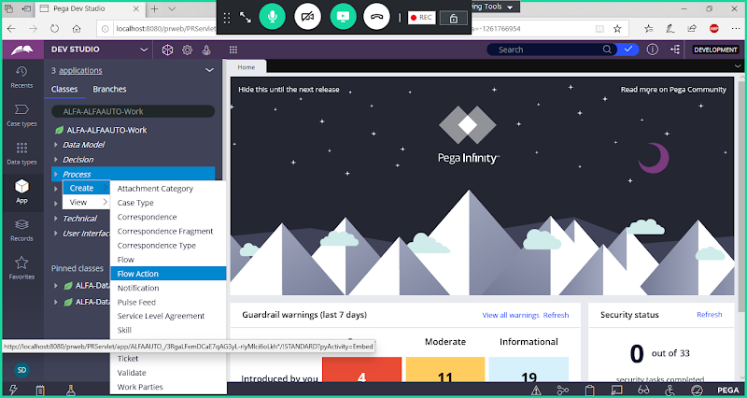

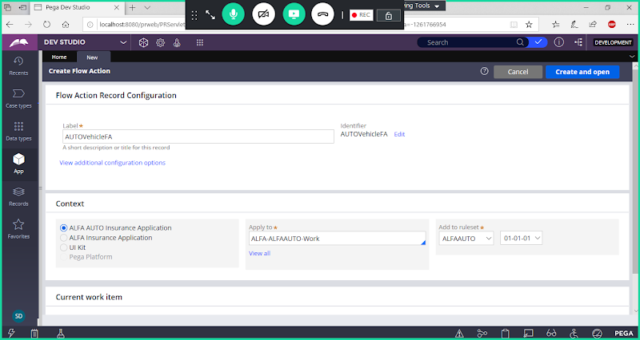

**open**

**Call Personal Vehicle Section in Base Rule**

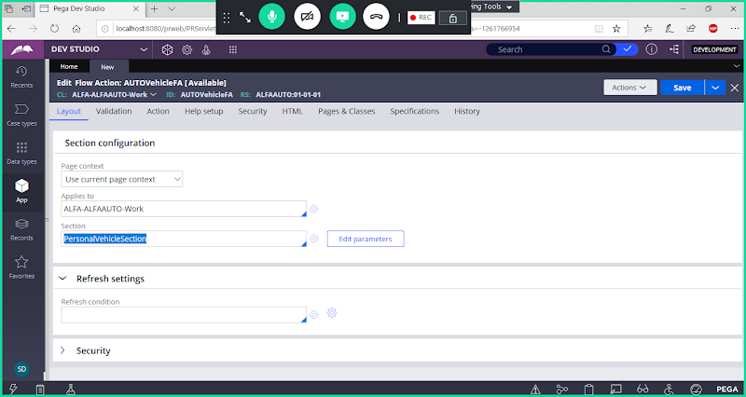

**Save Flowaction**

**This is Base Rule for Our Circumstance:**

**Now Add Circumstance Flowaction to map Commercial Vehicle Section:**

**From above Flowaction -> Go to Saveas dropdown-> Click on Specialize by Circumstance**

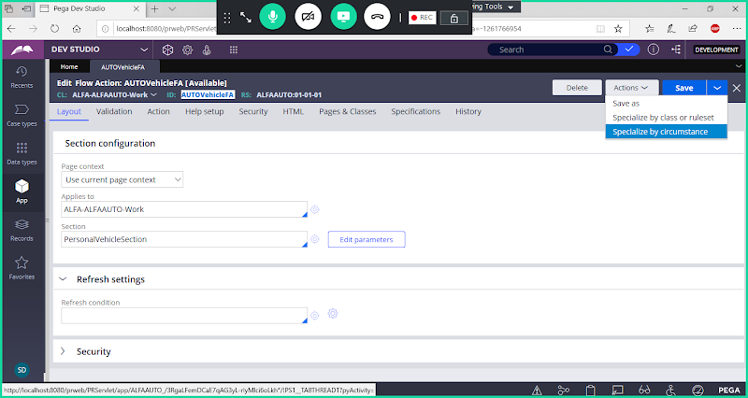

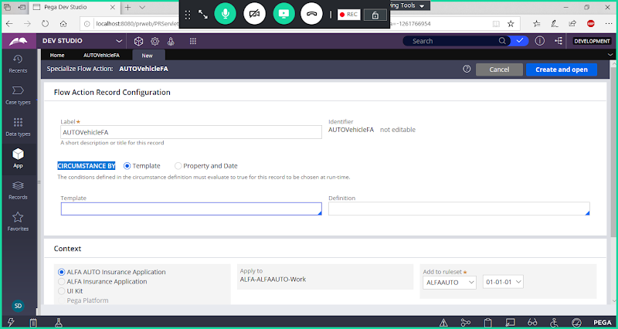

**Under Circumstance - Select Property & Date**

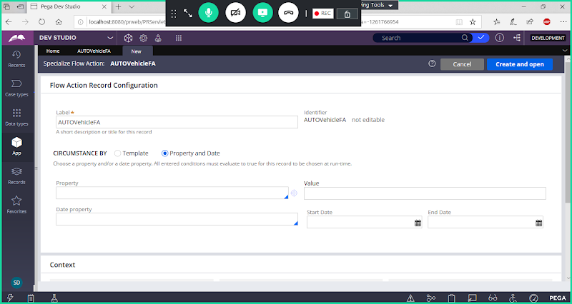

**Select Property: InsuranceType = CV**

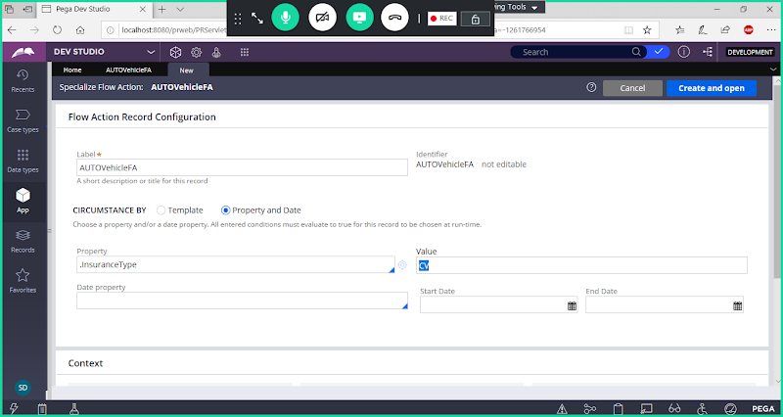

**Open**

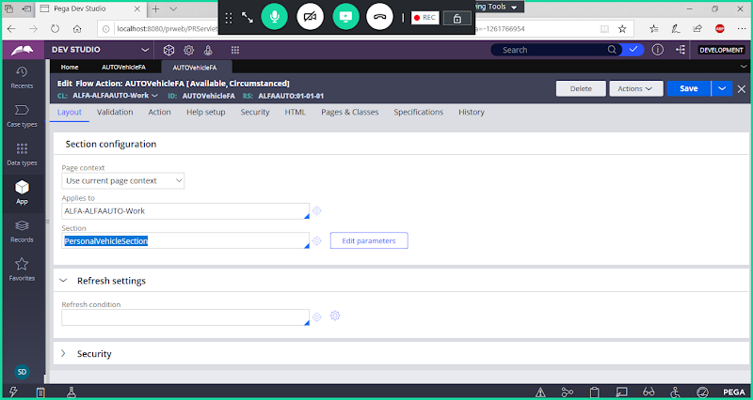

**Remove Personal Vehicle Section & Add Comm Vehicle section**

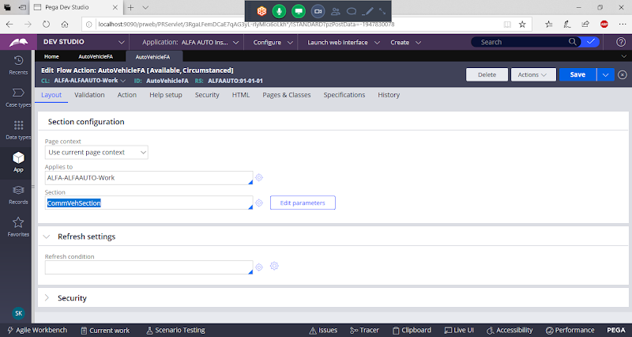

**Save Flowaction**

**Now Refresh Explorer:**

**Expand Pointer**

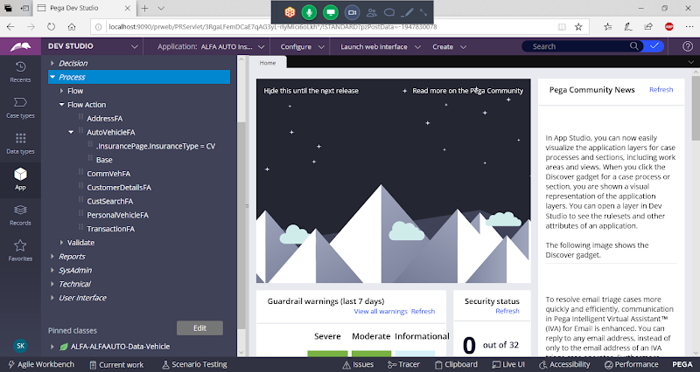

**Add AutoVehicle Fa in Insurance Flow.**

**Customize the flow design:**

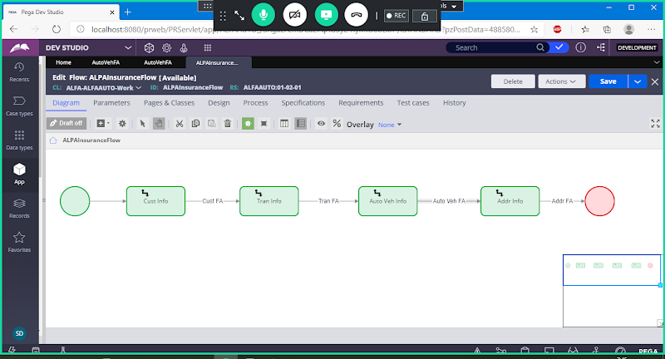

**Now After Customization the flow design will look like this as shown in next screen shot.**

**Update Label for Vehicle Assignment & Add Auto Vehicle Flowaction**

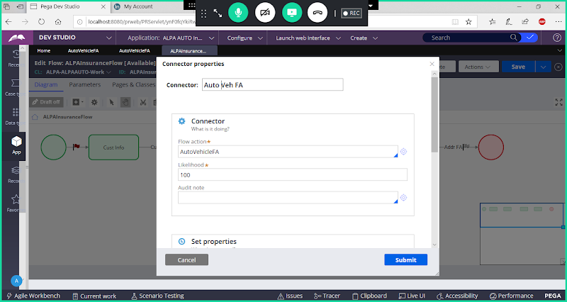

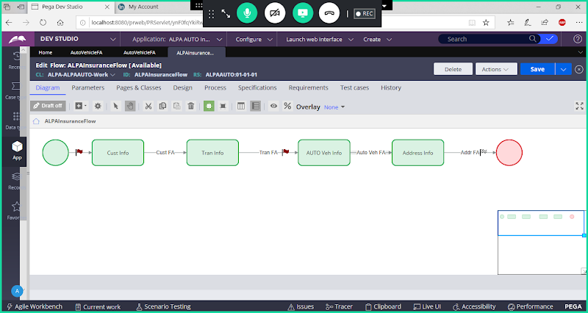

**Save**

**Run the Flow:**

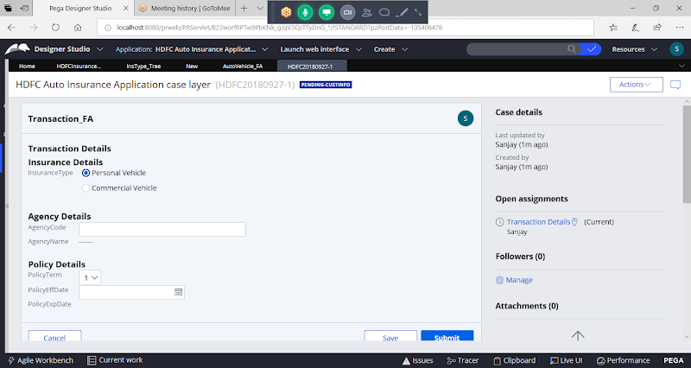

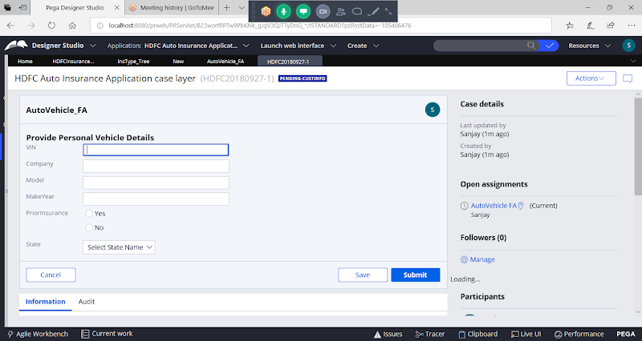

**Circumstance is one of the alternate solution for decision Making in Few Scenarios. Only when adding multiple if conditions with OR logic we can use circumstance.**

**Diff B/w Decision Tree & Circumstance:**

**- In Both OR Logic will apply b/w conditions**

**- In Decision Tree we can call other Decision Rules, but In Circumstance I can't call other Decision Rules**

**- In Decision Tree we can Add Nested if Conditions but not possible in Circumstance**

**- Circumstance is not a complete alternate for Decision tree, it is only used in some screnarios as alternate for Decision when applying OR conditions for Single /Multiple Properties.**

**=======**

**To Work on Multi Property Circumstance (Template) use Below Rules:**

**1- Circumstance Template**

**2- Circumstance Definition**

**Both rules we can create under Technical Category.**

**1- Circumstance Template: In this we will add all properties used in the condition**

**2- Circumstance Definition- For properties we are going to assign condition values**

**How to Add a Circumstance Template :**

**Using this rule we can add Properties**

**Technical -> Circumstance Template**

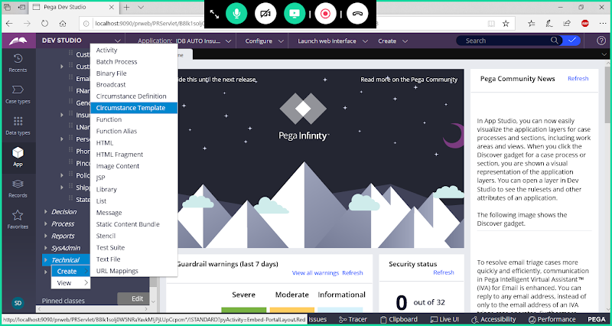

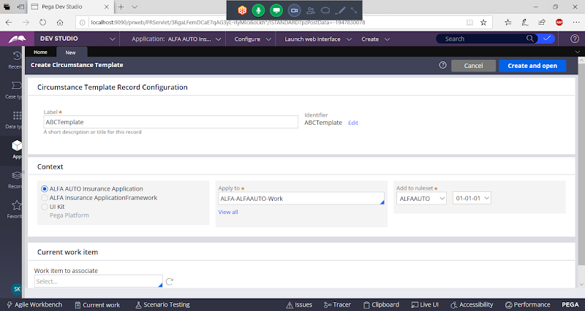

**Open**

**Select  Property Names**

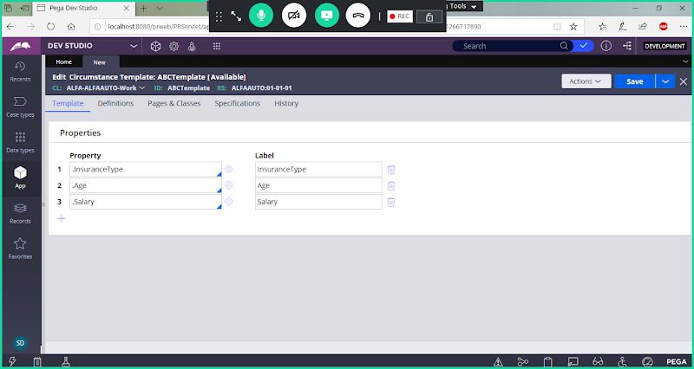

**Save Circumstance Template:**

**Now Create Circumstance Definition:**

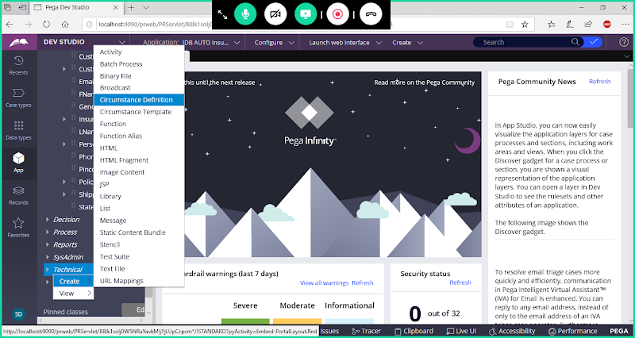

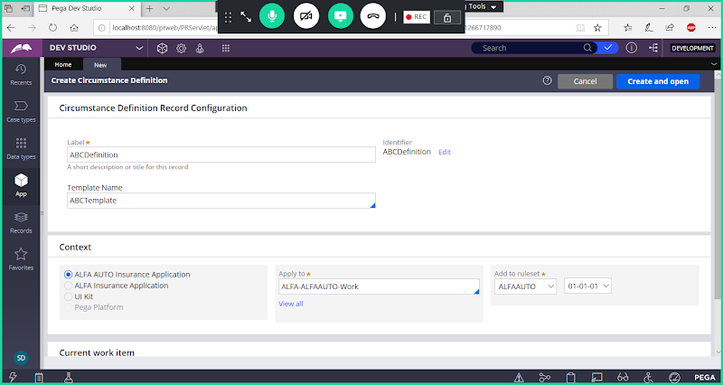

**Open**

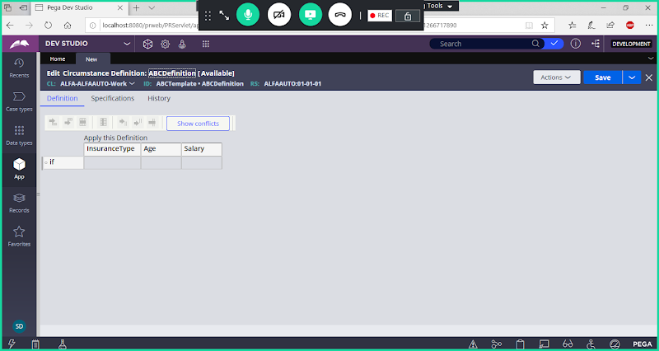

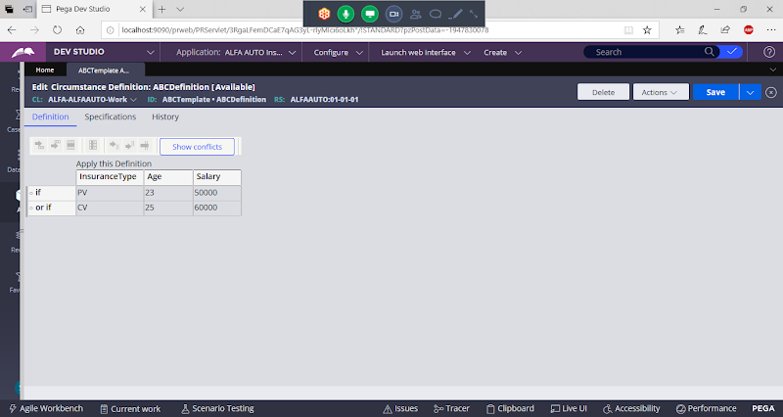

**Save Circumstance Definition**

**Open PersoanlVehicle FA**

**Select Specialize by Circumstance**



